**Exercise 1**

**c)**

num = [0 0 1]

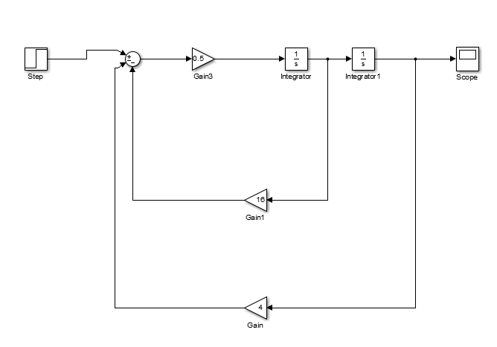denum = [2 4 16]

[A,B,C,D] = tf2ss(num,denum)

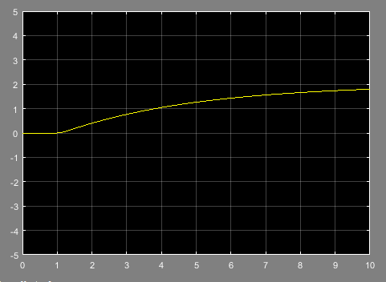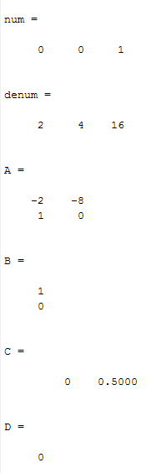

**d)**

**Exercise 2**

**c)**

**(a)**

num = [0 6 0]

denum = [8 6 1]

[A,B,C,D] = tf2ss(num,denum)

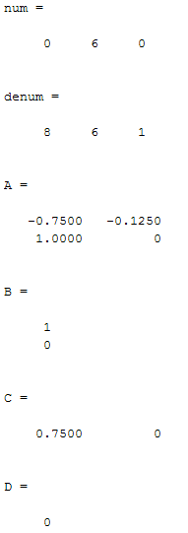

**(b)**

num = [0 0 1]

denum = [8 (4./3) 1]

[A,B,C,D] = tf2ss(num,denum)

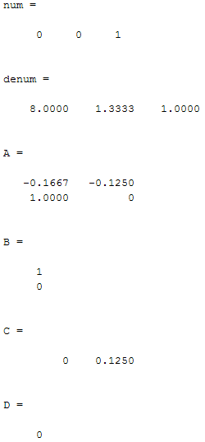

**(c)**

num = [1 0 0]

denum = [1 1./6 1./8]

[A,B,C,D] = tf2ss(num,denum)

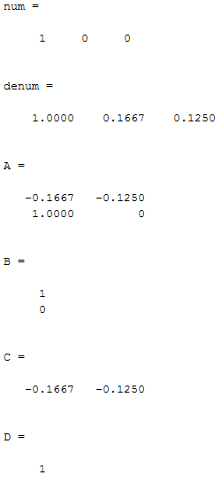

**d)**

